**PC649**

Summer Internship

Project Report-2020

**Internship Details:**

Project - NGO Finder

Internship Start Date : May, 2020 Internship End Date : August, 2020

**Mentor:**

Prof. Priyanka Singh DAIICT, Gandhinagar Gujarat - 382007

**Submitted To:**

Prof. Saurabh Tiwari

**Submitted By:**

Smit Shah (201912025)

Pratik Shah (201912028)

Shrenik Dalal (201912034)

**Table of Contents**

1. Introduction

2. Hardware and Software Requirements

3. Methodology

4. Design

5. Snapshots

6. Coding

7. Summary and Lessons Learnt

**Introduction:**

There are numbers of potential donor in the country who wants to donate to the NGOs or any other community but the only problem is that they do not find any place to do it around or some of them don't have time to visit the institute themselves for the kind cause. Here we give the solution as NGO Finder.

NGO Finder is the bridge between User/Donor and NGO where they can connect to each other and also the user can donate to the NGO of his/her choice. NGO listed can be anywhere within the jurisdiction of India. The NGOs have to first register themselves on the NGO side of the web app so that their information can be displayed to the user on the Donor side of the web app. At the home page of the Donor side the user can view the NGOs as per its Nature of Product such as Health, Education, etc. Selecting anyone of the Nature of Product will take user to the list of NGOs working in that field and there the User can donate amount of his/her choice to the NGO selected via Paytm's platform.

User can view the news aggregated from newsapi.org by selecting the news tab in the menu bar. User can also view the gallery of the NGO by clicking on the About Us tab. Also there is a option to contact the representatives of the web app by selecting the Contact Us tab in the menu.

**Hardware and Software Requirements:**

Developer's Side Client's Side

|  |  |
| --- | --- |
| Tools | Computer/Laptop (Visual Studio Code, Github) |
| Hardware | **32/64 bit Machine** |
| OS | **Windows** |
| RAM | **4 GB Recommended** |
| Web Browser | **Chrome**  **Firefox**  **Edge**  **Safari**  **Opera** |

|  |  |
| --- | --- |
| Tools | Computer, Laptop |
| Hardware | **32/64 bit Machine** |
| OS | **Windows / MacOS / Linux** |
| RAM | **4 GB Recommended** |
| Web Browser | **Chrome**  **Firefox**  **Edge**  **Safari**  **Opera** |

**Methodology:**

Iterative Waterfall Model:

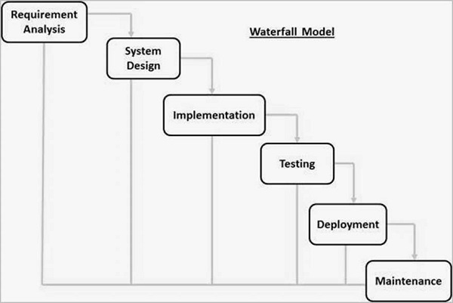

**Design:**

**Sequence Diagram:**

[**Images\Diagrams\Sequence\NGO.jpeg**](Images/Diagrams/Sequence/NGO.jpeg)

[**Images\Diagrams\Sequence\Login.jpeg**](Images/Diagrams/Sequence/Login.jpeg)

[**Images\Diagrams\Sequence\SignUp.jpeg**](Images/Diagrams/Sequence/SignUp.jpeg)

[**Images\Diagrams\Sequence\Donor.jpeg**](Images/Diagrams/Sequence/Donor.jpeg)

**Usecase Diagram:**

[**Images\Diagrams\Usecase.jpg**](Images/Diagrams/Usecase.jpg)

**Snapshots:**

Donor Side: [**Images\Donor SS**](Images/Donor%20SS)

NGO Side: [**Images\Admin SS**](Images/Admin%20SS)

**Coding:**

**Technologies used:**

**FrontEnd:** AngularJs, Bootstrap, Angular Material

**BackEnd:** Node.Js Express

**Database:** MySQL

**Code Link:**

**NGO Side FrontEnd:** <https://github.com/pratikshah98/ngofrontend.git>

**Donor Side FrontEnd:** <https://github.com/pratikshah98/donorfrontend.git>

**BackEnd:** <https://github.com/pratikshah98/ngobackend.git>

**Summary:**

The aim of this web app is to increase more awareness about NGOs to people and help people donate using to NGO of his/her choice.

**Lessons Learned:**

1. Learnt Angular CLI which is one of the best Framework for FrontEnd Development.
2. Learnt Node.js Express for Backend Development.
3. Learnt MySQL for the Database integration.
4. Got familiar with Basics of Git (for version control).
5. Learnt how to work in a team.
6. Team members were geographically dispersed which gave a company like experience of future scenario.
7. Got familiar to Bootstrap and Angular Material for Designing.
8. Learnt about Time Management.